
Dashboard Design

Date | 26 October 2026
Team ID | Individual
Project Name | Electric Vehicle Market Analysis Dashboard
Maximum Marks | 5 Marks

Creating an effective dashboard involves thoughtful design to ensure that the presented information is clear, relevant, and easily understandable for the intended audience. Here are some key principles and best practices for dashboard design
Activity 1: Interactive and visually appealing dashboards
Creating interactive and visually appealing dashboards involves a combination of thoughtful design, effective use of visual elements, and the incorporation of interactive features. Here are some tips to help you design dashboards that are both visually appealing and engaging for users so take care of below points
- Clear and Intuitive Layout
- Use Appropriate Visualizations
- Colour and Theming
- Interactive Filters and Slicers
- Drill-Down Capabilities
- Responsive Design
- Custom Visuals and Icons
- Use of Infographics

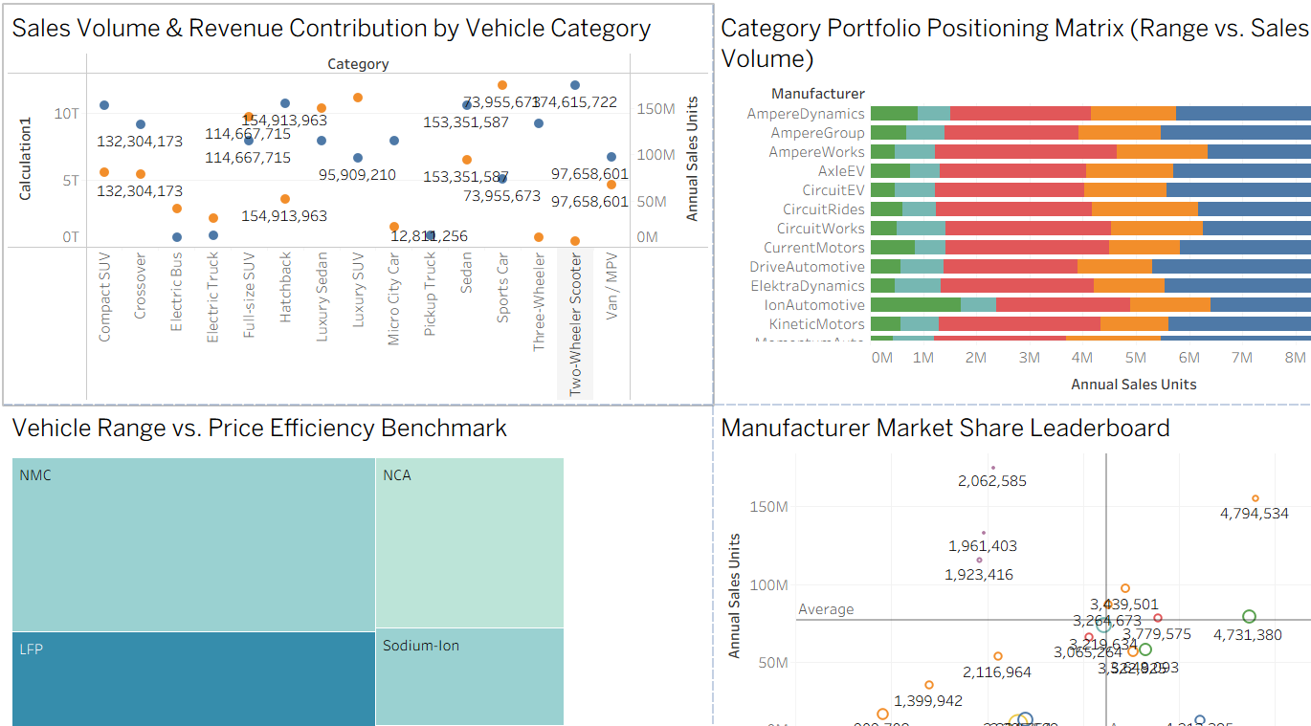
Dashboard 1: Sales volume, category portfolio, range vs price and manufacturer market share
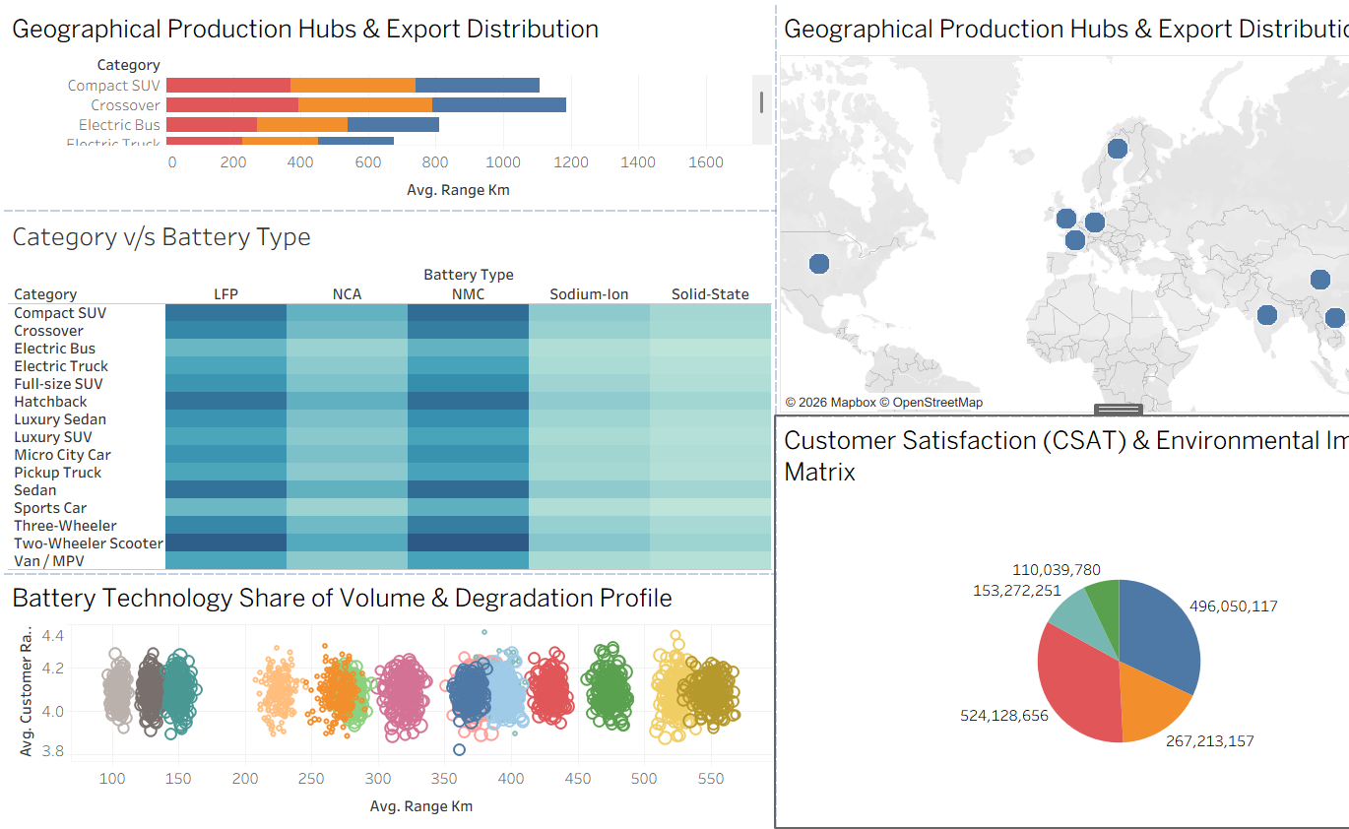
Dashboard 2: Production hubs, category vs battery type, battery degradation profile and CSAT & environmental impact
Major outcomes from the Electric Vehicle Market Analysis dashboards:
- Market Scale: Total Annual Sales Units across the five segments in the CSAT & Environmental Impact pie add up to roughly 1.55B units, giving the overall size of the EV market covered by the data.
- Sales Concentration: The two largest segments (about 524.1M and 496.1M units) together account for roughly 65.8% of total annual sales units, while the smallest segment contributes only about 7.1% (110.0M units).
- Highest-Volume Category: Two-Wheeler Scooter shows the highest labelled sales volume at about 174.6M units, with several other categories labelled between roughly 95M and 155M units.
- Battery Technology Mix: NMC and NCA take the largest tiles in the range vs price treemap, and the Category v/s Battery Type heatmap is darkest for LFP and NMC across most vehicle categories, while Sodium-Ion and Solid-State are lightest.
- Range Leaders: Crossover (about 1,180 km) and Compact SUV (about 1,100 km) lead the visible categories on Avg. Range Km, followed by Electric Bus at about 810 km.
- Manufacturer Performance: A small group of manufacturers stands out at roughly 4.79M and 4.73M annual sales units, while most others cluster around or below the market average line.
- Global Production Hubs: Production hubs are concentrated in Western Europe and the Nordics, with further hubs in North America and South and East Asia.
- Range vs Customer Satisfaction: Battery technologies form distinct clusters between about 100 and 550 km of average range, yet average customer ratings stay within a narrow 3.8 to 4.4 band, so longer range alone does not guarantee higher satisfaction.

Activity 2
Publish Dashboard on Tableau Public and Paste the Dashboard Public link below:
[Paste your Tableau Public dashboard link here after publishing]

